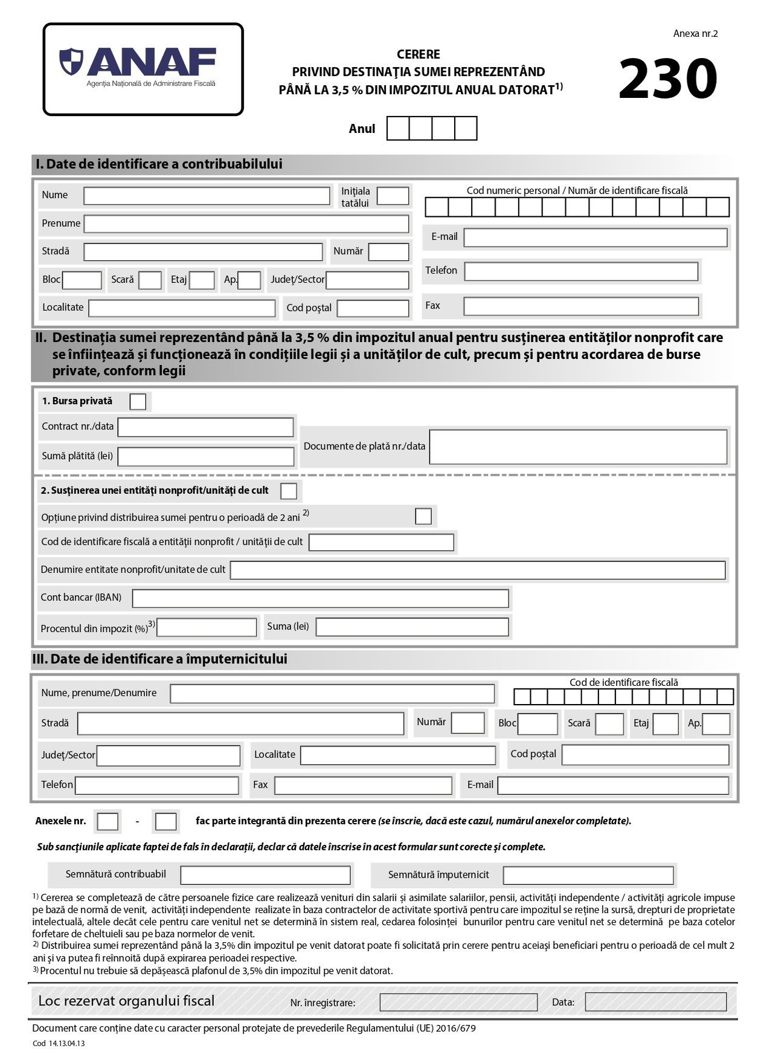
2 0 2 5

X

31853156

ASOCIATIA MOASELOR INDEPENDENTE

RO13BACX0000000865385001

3.5%

